**Question 1:** Write a function to compute the square root for a number, as described in slides 29-30.

**Question 2:** Write a function to estimate the PI number using randomness, as described in slides 31-35.

**Question 1**

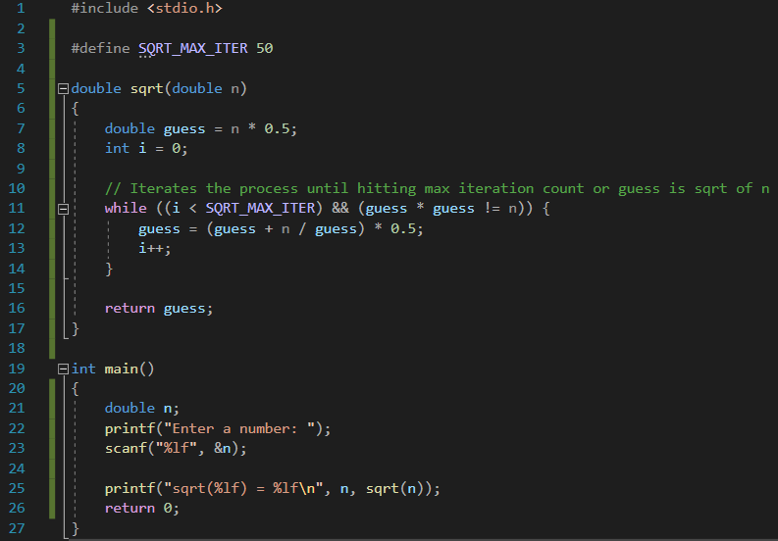



**Question 2**



